FIM Journal

*This document is a log of issues, questions, and ideas we’ve discussed around the FIM*

## 9/4/2020 Updated Long-Term Budget Projections

In September, the CBO updated their long-term budget projections for [2020 - 2030](https://www.cbo.gov/publication/56542). Subsequently, the following changes were made to the FIM:

1. ~~Updating the NIPAS translation of the budget. See “workbook” sheet in the “~~[~~NIPAS translation workbook~~](https://brookingsinstitution.sharepoint.com/sites/hutchinscenterteam/Shared%20Documents/Projects/Fiscal%20Impact/09-2020/Data/NIPAS%20translation%20workbook.xlsx?web=1)~~” excel file.~~
   1. ~~Calculate the growth rates of NIPA line items in the Budget from the May 2019 update to the September 2020 update~~
   2. ~~Apply the growth rates to the last NIPAs budgetary translation from June 2019~~
   3. ~~Update the “cbo_nipas_budget_annual” with the new calculated numbers from (b).~~
2. Remove the applicable add factors in the calculations.r code. The following were removed
   1. add_state_expenditures
   2. federal_corp_taxes and federal_norcorp_taxes
3. Although we first thought the addons for federal health and federal social benefits should be removed we have to still include and adjust them in the code because without doing so the updated levels for Q2 2020 will continue indefinitely (as if the legislative changes continue forever). So, we add in the add factors for these federal portions to account for the changes in spending and timing for the various legislation.
4. Updated the remaining state and federal add-ons using the “add-ons” tab in the [LSFIM_KY_v2](https://brookingsinstitution.sharepoint.com/sites/hutchinscenterteam/Shared%20Documents/Projects/Fiscal%20Impact/COVID-19%20Changes/September/LSFIM_KY_v2.xlsx?web=1) file
   1. Updated the historical data (mainly 2020 q2) with the revised numbers from BEA
   2. Update the legislation data using revised estimates from the [CBO September release](https://www.cbo.gov/system/files/2020-09/56517-Budget-Outlook.pdf)
   3. Reran the FIM without any addons and update the no-add on columns appropriately
   4. New add-ons will be calculated automatically. Update r code with the new figures
5. Redirecting the Cons Grants timing
   1. Why? BEA has put all the grants (coronavirus relief funds and education grants) in the second quarter of 2020. We believe that the timing of the grants, although having been provided to states now, will be spent different. We will input our timing assumptions into the data by doing the following:
   2. For the second quarter of 2020 we will force the data to equal the cgrants levels without covid (181.52) [calculated in the addons file referenced below]. This is in line 112 in the fim_calculations.r file.
   3. Smooth the legislation spending evenly over the next 6 quarters (from q3 2020 to q4 2021). See the Federal Cons Grants category in the “add-ons” tab in the [LSFIM_KY_v2](https://brookingsinstitution.sharepoint.com/sites/hutchinscenterteam/Shared%20Documents/Projects/Fiscal%20Impact/COVID-19%20Changes/September/LSFIM_KY_v2.xlsx?web=1) file
6. Updating the MPCs for Social Benefits and MPCs – see the sheet “MPC” in “[LSFIM_KY_v2](https://brookingsinstitution.sharepoint.com/sites/hutchinscenterteam/Shared%20Documents/Projects/Fiscal%20Impact/COVID-19%20Changes/September/LSFIM_KY_v2.xlsx?web=1)” file
7. Adding the Wage Loss Assistance program to our add factors
   1. Why? CBO did not include executive action passed on August 12th which extended UI until December 6th, 2020 or until $44 billion have been disbursed. Whichever comes first. States have until September 10th, 2020 to apply and some have started to disburse funds. These states will get $300 per week in enhanced unemployment benefits.
   2. As of 9/9/2020 47 states have been approved, 2 states have applied but not yet approved, and 1 state will not apply. Of approved states, 11 have already started disbursing funds and 12 more will do so mid to late September. The remaining states have not announced when their programs start or will start in October. Therefore, most spending will happen in Q4 2020 (calendar year)
   3. Indicated as “Trump UI” in the main tab of “[LSFIM_KY_v2](https://brookingsinstitution.sharepoint.com/sites/hutchinscenterteam/Shared%20Documents/Projects/Fiscal%20Impact/COVID-19%20Changes/September/LSFIM_KY_v2.xlsx?web=1)” we added. We did 25% in 2020 Q3 and the remaining in 2020 Q4. These were also annualized. This gets added to total Federal UI and subsequently will update the rest of the spreadsheet and add factors accordingly.
   4. Further documentation can be found under COVID-19 Changes/September/WLA. Data for each states program can be found in WLA/data/wla.csv and an R notebook called “summary.nb.html” summarizing the data can be found under WLA/code.
   5. Dashboard on unemployment insurance [here](https://tcf.org/content/report/unemployment-insurance-data-dashboard/?agreed=1)
   6. Useful data [here](https://docs.google.com/spreadsheets/d/1Wz98hOMQpYBUH8gt6udNv4xKExc66ioD_H1SP9-9J6k/edit#gid=0)
8. Change code so growth rates consider CBO quarterly data.
   1. Currently, we ignore data for growth rates until all four quarters come out
   2. Sheet of CBO growth rates
   3. Check our fim projections match with CBO
9. Louise overriding growth rate of S&L purchases with her own assumptions
   1. 2020 Q3 = -5%
   2. 2020 Q4 = 4%
   3. In projections code before the bigger mutations
10. To do next time: state health outlays should be state health spending

## 6/23/2020 Coronavirus Legislation and Forecast

There were several legislations passed in response to the 2020 coronavirus pandemic. The forecast was initially removed due to lack of scores, but the forecast will be reinstated with the following changes:

1. We all include add factors for the variables of interest (taxes, transfers, and spending) on both a federal and state & local level. See the tab “add factors” tab in the “[covid_quartely_outlays](https://brookingsinstitution.sharepoint.com/:x:/s/hutchinscenterteam/Eamh8nVATpFNg0RsN1V7C0gBjFi38aEQkJpETlmaJ4dQsg?e=qYn4fx)” excel file in the “COVID-19 Changes/May” folder. These are based off legislation and automatic changes to the variables. Helpful resources:
   1. Scores for legislations: H.R. [6074](https://www.cbo.gov/system/files/2020-03/hr6074.pdf), H.R. [6201](https://www.cbo.gov/system/files/2020-04/HR6201.pdf), H.R. [748](https://www.cbo.gov/system/files/2020-04/hr748.pdf)
   2. Slide 11 of [Presentation](https://www.bea.gov/system/files/2020-05/Impact-of-COVID-19-on-BEAs-Economic-Accounts_0.pdf): Impact of Covid-19 on BEA’s Economic Accounts
   3. [Pdf text](https://www.bea.gov/system/files/2020-05/COVID-19%20Pandemic-Federal%20Recovery%20Legislation%20and%20the%20NIPAs.pdf) explanation: COVID-19 Pandemic: Federal Recovery Legislation and the NIPAs
   4. [Interim Economic Projections for 2020 and 2021](https://www.cbo.gov/publication/56351)
2. We will add in subsidies to the code
   1. See word document “updating code for subsidies”
   2. For the figures output, the subsidies should be included in total taxes and transfer
3. We will change the MPCs to reflect the behavioral changes and the inclusion of subsidies. See the table below:

|  |  |  |  |  |
| --- | --- | --- | --- | --- |
| **Type** | **Current MPC** | **Current Timing** | **Proposed MPC** | **Proposed Timing of Consumption** |
| Social Benefits | 0.9 | Evenly over 4 quarters | *unchanged* | See MPC tab in spreadsheet (#1) for timing change |
| Health Outlays | 0.9 | Evenly over 4 quarters | *unchanged* | *unchanged* |
| Corp Taxes | -0.4 | Evenly over 12 quarters | *unchanged* | *unchanged* |
| Non-corp Taxes | -0.6 | 8 quarters: 20% in Q1,2. 60% evenly over last 6 quarters | See MPC tab in spreadsheet (#1) for timing change | See MPC tab in spreadsheet (#1) for timing change |
| Subsidies | *new* | *new* | See MPC tab in spreadsheet (#1) for timing change | See MPC tab in spreadsheet (#1) for timing change |

1. We will now reattribute state unemployment spending to states and not to federal
   1. Pull haver code: “ GFTFBUSX@USNA”
   2. In projections file:
      1. #reattribute state unemployment from federal back to state
      2. xx$gftfbusx = xx$gftfbusx/1000 #translate from millions to billions
      3. xx$gftfp = xx$gftfp - xx$gftfbusx
      4. xx$gstfp = xx$gstfp + xx$gftfbusx
      5. add to calculation of forward values
2. Remove old legislation from code:
   1. HR 1865
   2. HR 6074 Addons Calculations

## 12/19/19 Effects Of H.R. 1865, The Further Consolidated Appropriations Act, 2020

House passed spending deal (consistent with the summer 2019 act that raised the discretionary spending caps for FY 2020 and FY 2021). The spending deal applies to the remaining quarters in FY 2020.

The deal does nothing to the discretionary caps, ($1.29 for FY2020), but it does adjust the “cap adjustments” (these are flexible pieces of the caps, like disaster relief spending), upwards by about $18 billion (Louise’s math—we’re checking).

To incorporate this into the forecast, we’ll boost government purchases by $18billion for the rest of FY20, grow that 18 by nominal potential for FY21 and 22, and add those amounts onto the projected purchases for those years.

The bill also has several tax revenue provisions. It lets a bunch of tax extenders expire, so taxes go down. To incorporate these, we will:

* Take off the CBO-scored declines in health insurance taxes (treat these like excise taxes):
  + <https://www.cbo.gov/system/files/2019-12/hr1865.pdf>
  + Treat them like excise taxes
  + About $2.1, 1.3, and 23 billion in 2020-22
* Take off the CBO-scored declines in other taxes:
  + <https://www.cbo.gov/system/files/2019-12/Supplemental%20Table%201%20-%20Division%20N.pdf>
  + <https://www.cbo.gov/system/files/2019-12/hr1865_0.pdf>
  + Treat them like half personal and half corporate taxes for now
  + About 32, 10, 4.5 billion in 2020-22

See ‘Dec 2019 Legislation.xls’ worksheet for the math.

|  |  |  |  |
| --- | --- | --- | --- |
| [Took the revenue line items straight from JCT: https://www.jct.gov/publications.html?func=startdown&id=5237](https://www.jct.gov/publications.html?func=startdown&id=5237) | FY |  |  |
|  | **2020** | **2021** | **2022** |
| **ECONOMIC VARS (percent)** |  |  |  |
| Projected Real Potential | 2.1 | 2.1 | 2.1 |
| Projected Inflation | 2.1 | 2.1 | 2.1 |
|  |  |  |  |
| **REVENUE PROVISIONS, Millions of Dollars** |  |  |  |
| DIVISION N - HEALTH AND HUMAN SERVICES EXTENDERS | -1,589 | -15,912 | -23,417 |
| DIVISION O - SETTING EVERY COMMUNITY UP FOR RETIREMENT | -973 | -574 | -282 |
| DIVISION Q - REVENUE PROVISIONS –  **Most provisions sunset 12/31/ 2020** | -32,483 | -10,506 | -4,501 |
|  |  |  |  |
| **REVENUE ADD-ONS, assuming sunsetting provisions do not sunset** |  |  |  |
| Excise (Non-corporate taxes) | -1,589 | -15,912 | -23,417 |
| Other (Non-corporate taxes) | -16,728 | -17,427 | -18,145 |
| Non-Corporate Taxes | -18,317 | -33,339 | -41,562 |
| Corporate Taxes | -16,242 | -16,920 | -17,617 |
|  |  |  |  |
| **REVENUE TOTALS** |  |  |  |
| Non-Corporate Taxes - OLD | 3,414,000 | 3,549,000 | 3,693,000 |
| Non-Corporate Taxes - NEW | 3,395,683 | 3,515,661 | 3,651,438 |
| Corporate Taxes - OLD | 243,000 | 261,000 | 286,000 |
| Corporate Taxes - NEW | 226,759 | 244,080 | 268,383 |
|  |  |  |  |
| **SPENDING PROVISIONS, Millions of Dollars** |  |  |  |
| Estimated raise of CAP ADJUSTMENTS | 18,726 | -- | -- |
|  |  |  |  |
| **SPENDING ADD-ONS, assuming cap adjustments continue to rise** |  |  |  |
| Estimated raise of CAP ADJUSTMENTS | 18,726 | 19,508 | 20,312 |
|  |  |  |  |
| **SPENDING TOTALS, assuming cap adjustments continue to rise** |  |  |  |
| Federal Purchases - OLD | 1,432,700 | 1,471,100 | 1,502,800 |
| Federal Purchases - NEW | 1,451,426 | 1,490,608 | 1,523,112 |

## 11/19

What explains big jump in government social benefits?

Refundable tax credits, maybe because of change in EITC benefits related to adoption of C-CPI-U as automatic adjustment?

<https://www.irs.gov/credits-deductions/individuals/earned-income-tax-credit/eitc-income-limits-maximum-credit-amounts-next-year>

Are the refundable tax credits actually reported on a cash basis, in which case these could be changes in the EITC and child tax credits from the 2017 tax law?

<http://www.cbo.gov/sites/default/files/cbofiles/ftpdocs/89xx/doc8917/appendixd.12.1.shtml>:

“Personal Taxes. Although personal taxes are not recorded on an accrual basis in the NIPAs, BEA nevertheless attempts to avoid large, distorting upward or downward spikes in personal disposable income that result from timing quirks. Such quirks occur each year in April, for example, when most final settlements for the previous year’s personal taxes are paid. In the NIPAs, therefore, those settlements are evenly spread over the four quarters of the calendar year in which they are paid. (As with accrual accounting, that treatment avoids spikes. Unlike accrual treatment, however, it does not move payments back to the year in which the liabilities were incurred.) Such "smoothing" can alter the relationship of the NIPAs and the budget accounts for various fiscal years because it shifts some receipts into the last quarter of the calendar year and thus into the following fiscal year.[14](http://www.cbo.gov/sites/default/files/cbofiles/ftpdocs/89xx/doc8917/appendixd.12.1.shtml" \l "60)”

## 10/29

We are now applying specific deflators for the different pieces of state, local, and federal purchases. Particularly for the pieces that we’re redistributing between the federal and state sectors. E.g., capital grants to states, which we now attribute to federal purchases, should get the deflator for state and local investment, because that’s how it’s being spent.

I.e., keep the nominal categories separate, then use specific deflators to calculate the contributions for the different pieces, then add the contributions together to form the total contribution for state and local purchases or federal purchases.

As a check, I took our new, adjusted contributions for state & loc and for federal purchases, added our “neutral” measure back to both, and added the two together, and we get BEA’s numbers for total government contributions to GDP growth.  The neutral measure is just (real potential gdp growth)*(lagged nominal purchases / lagged nominal GDP). See chart below.

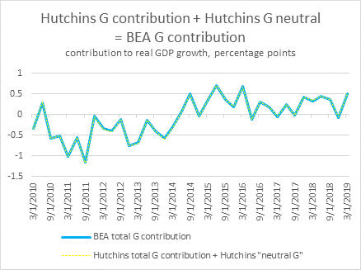

FYI, here are the neutrals for the federal and s&l pieces, both before and after reattributing the grants to federal:

*With no adjustment to attribute grants to federal:*

Federal neutral = ~0.14

State and local neutral = ~0.23

*With adjustment to attribute grants to federal:*

Federal neutral = ~0.16

State and local neutral = ~0.21

## 10/20

There is a BEA line item for Federal Government grants to states for health, Medicaid (**Table 3.24U. Federal Grants-in-Aid to State and Local Governments, line 14-15)**. We’ve been estimating the Federal Medicaid grants using FMAPs (we get pretty close), but we can start using this line item now. But we want to ensure that we’re not attributing any non-purchase grants to federal purchases mistakenly. Those should all go into federal transfers, not federal purchases.

Should we also be including federal capital grants to states in federal purchases?

## 10/17 question from CBO about backing out the implied potential growth rate we use.

See implied_poetentialGDPGrowth_Hutchins.xls for a replication.

**From:** John Seliski <[John.Seliski@cbo.gov](mailto:John.Seliski@cbo.gov)>  
**Date:** October 16, 2019 at 5:25:15 PM EDT  
**To:** Louise Sheiner <[LSheiner@brookings.edu](mailto:LSheiner@brookings.edu)>  
**Cc:** John Kitchen <[John.Kitchen@cbo.gov](mailto:John.Kitchen@cbo.gov)>  
**Subject:** **FIM for federal, state, and local government purchases**

Hi Louise,

I am an analyst at the Congressional Budget Office and I have a question related to the government purchases numbers you are reporting in the Hutchins Center Fiscal Impact Measure (FIM). I’m not sure which real potential GDP series the FIM uses (CBO’s?), but I tried to back out the implied potential growth rates and they look a bit strange.

In your methodology, you write:

“The FIM for purchases is defined as the actual contribution of real government purchases to GDP less the contribution that would have prevailed if real purchases were growing with potential GDP. To calculate the actual contribution of real purchases to GDP, we take the growth rate of real government purchases times their share of GDP; for the counterfactual we perform the same calculation but use the growth rate of real potential GDP.”

To back out your implied real potential GDP growth rates I used the following relationship:

FIM = contrib – (real potential GDP growth)*G(-1)/Y(-1)

contrib – FIM = (real potential GDP growth)*G(-1)/Y(-1)

real potential GDP growth = (contrib – FIM)*Y(-1)/G(-1)

When I do this calculation for both ‘federal’ and ‘state_local’ FIMs in your raw data, I get different implied potential growth rates and the numbers look too volatile and large for real potential GDP growth. Am I doing something wrong? Any insights would be greatly appreciated. I have attached the simple calculation I did in a workbook. Thank you!

**John Seliski**  
Macroeconomic Analysis Division

Congressional Budget Office

202-226-2766 | [john.seliski@cbo.gov](mailto:john.seliski@cbo.gov)

Here’s a draft of what I would reply to John, for us to discuss.

…

Hi John,

Thanks for your interest and question. We do use the CBO estimates of real potential growth, and your approach to backing out the potential growth rate we use is correct. However, the calculations produce the wrong implied growth rate because we adjust the government purchases data in our construction of the FIM to reattribute some grants-in-aid to states to the federal government. This means that backing out the implied growth rate from the BEA line items for government purchases and their contributions to percent change in GDP does not quite work. I have modified the spreadsheet you sent to include our adjustments to the purchases numbers and to take your approach to backing out the potential rate.

More specifically, we add back **non-Medicaid** **grants-in-aid** to state and local governments **to federal purchases** by (a) calculating the portion of grants-in-aid to state and local governments (Table 3.2.31) that is not Medicaid-related using the Federal Medical Assistance Percentage (FMAP) for Medicaid, (b) adding this dollar amount back to federal purchases, and (c) subtracting this dollar amount from state and local purchases. Once you are equipped with these adjusted purchases series, and have calculated new contributions to GDP growth based on them, you will see in the attached sheet that you can back out the appropriate real potential GDP growth estimate. There is some small residual between the backed-out series and the CBO series that I think is due to the flip-flopping between annualized and quarterly rates in the process.*

I hope this is helpful, and we’re happy to answer any more questions you have.

…

*when I back out the implied growth rate using my non-annualized data and my approach, I get exactly CBO’s numbers for potential GDP. But I can’t figure out where the residual is coming from, for the life of me.

Sage

## 10/17 exchange

**From:** "Nalewaik, Jeremy" <[Jeremy.Nalewaik@morganstanley.com](mailto:Jeremy.Nalewaik@morganstanley.com)>  
**Date:** October 17, 2019 at 12:51:50 PM EDT  
**To:** Louise Sheiner <[LSheiner@brookings.edu](mailto:LSheiner@brookings.edu)>  
**Subject:** **FIM**

﻿Hey Louise.  How have you been?  Been meaning to visit Brookings one of these days – hopefully soon.

Some chatter here amongst some of my colleagues about the sharp projected drop off in Brookings FIM.  A couple questions if you have time:

1. Why the negative contribution projections for S&L?  S&L budgets seem healthy (on average, of course there are exceptions) and S&L spending typically picks up late cycle.

First, it’s worth noting that we’ve updated our methodology recently so that the FIM now reflects contributions of fiscal policy beyond those that would occur if government purchases were growing with real potential GDP. So the negative projected contributions from state and local spending means we expect that sector to grow below potential, not to have a negative contribution to the headline GDP numbers in the way that BEA reports contributions. More generally, our forecast for state and local spending is consistent with CBO’s and has total spending in that sector moderate next year after the surge in investment spending this year. In addition, CBO assumes (and we follow) that the sector will experience almost zero productivity growth going forward, putting a lot of downward pressure on the forecasts for real growth.

1. What’s driven the large contributions from taxes and transfers and why the projected drop off next year?

The increase in the contribution from taxes and transfers this year has been driven mostly by **unexpectedly large tax credit payments** ([see Table 3.12U, 20](https://apps.bea.gov/iTable/iTable.cfm?reqid=19&step=2#reqid=19&step=2&isuri=1&1921=underlying)) and large Social Security transfer payments at the beginning of the year, associated mostly with the **COLA adjustments that went into place in January**. We assume these payments have a persistent effect on consumption—but our assumptions imply that effect will dissipate in 2020, explaining most of the drop off in that component’s contribution in 2020. We explain our assumptions about the consumption effects in our [methodology](https://www.brookings.edu/research/the-hutchins-centers-fiscal-impact-measure/). After that point, with no expected legislative changes, continued moderate growth in health spending, and some amount of real bracket creep, we expect the net effect of taxes and transfers to be about consistent with keeping the economy at potential.

Thanks,

Jeremy Nalewaik, Executive Director     
**Morgan Stanley | Research**1585 Broadway, 38th Floor | New York, NY  10036     
Phone: +1 212 761-3892     
[Jeremy.Nalewaik@morganstanley.com](mailto:Jeremy.Nalewaik@morganstanley.com)

## 9/20/2019 From the August 2019 CBO outlook, regarding Use it or Lose it Budget Authority

<https://www.nber.org/papers/w19481.pdf>

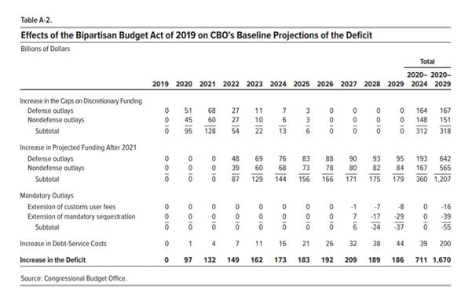

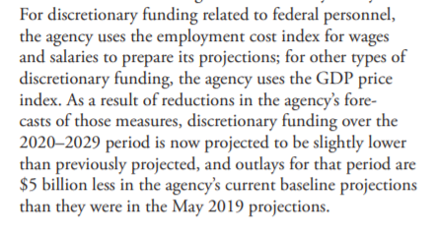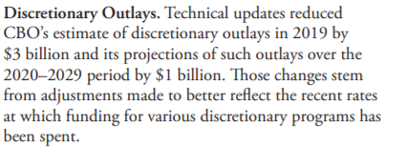

Use-it-or-lose it BA

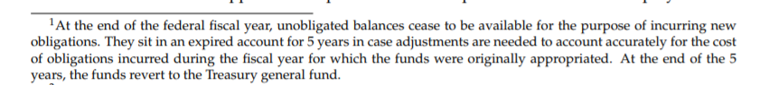

## 8/29 Revision to nominal potential GDP

We changed the code so that instead of using CBO’s estimates of nominal potential GDP and deflating it with our own GDP deflators where necessary, we use their estimates of real potential GDP. This is because (a) we can’t figure out what deflator is implicit in their nominals and (b) they only publish the potential estimates semi-annually; so their nominals for a few realized historical quarters are actually based on forecasts for inflation that might be really off. For example, the figure below shows CBO’s estimates for nominal potential GDP (as they publish it) in January 2019 (blue) and August 2019 (green). The revisions that affected our FIM significantly are outlined in red.

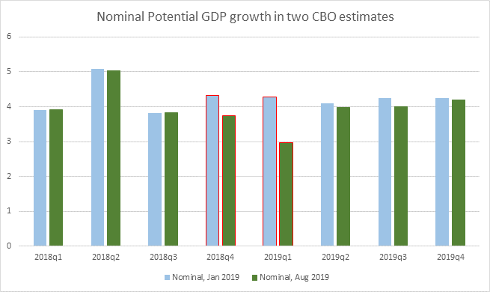

If, instead, we had just taken their estimates of real potential output growth, and created our own nominals using the realized GDP deflator, we would have gotten the following two series in January and August, again with the two quarters of interest outlined in red. This method results in smaller revisions.

